

# AMERICAN INTERNATIONAL UNIVERSITY–BANGLADESH (AIUB)

**FACULTY OF SCIENCE & TECHNOLOGY**

**DEPARTMENT OF ELECTRICAL AND ELECTRONIC ENGINEERING DIGITAL LOGIC AND CIRCUITS LABORATORY**

## FALL 2023-2024

**Section: Q, Group: 2**

## LAB REPORT ON

Studying different digital logic gates and designing basic logic gates using universal gates.

**Supervised By**

**DR. TANBIR IBNE ANOWAR**

**Submitted By:**

|  |  |  |
| --- | --- | --- |
| **Name** | **ID** | **Contribution** |
| NUSHRAT JAHAN | **22-46149-1** | Theory research & appendices writing |
| MD. FAHIM MURSHED | **22-46695-1** | Syntax writing, Resource Collecting |
| S.M. MUJAHID SOUROV | **22-49679-3** | Experimental Data, Analysis, Result |
| MD. ATIK ISHRAK SUJON | **22-46684-1** | Procedure, Multisim, MS Word |
| TRIDIB SARKAR | **22-46444-1** | Discussion writing, Reference, Questions & Answers |

Date of Submission: **, 2023**

# TABLE OF CONTENTS

|  |  |
| --- | --- |
| **TOPICS** | **Page no.** |
| 1. **Cover Page** | 1 |
| **II. Table of Contents** | 2 |
| **Abstract** | 3 |
| **Theory** | 3 |
| **Apparatus** | 6 |
| **Experimental Procedure** | 6 |
| **Circuit Diagram** | 6 |
| **Images** | 7 |
| **IC Configuration** | 12 |
| **MULTISIM** | 13 |
| **Discussion** | 18 |
| **References** | 18 |
| **Questions & Answers** | 19 |

**Title:**

Studying different digital logic gates and designing of basic logic gates using Universal gates.

**ABSTRACT:**

In this experiment, we gained knowledge about the characteristics of various logic gates and developed familiarity with digital trainer boards and digital integrated circuits (ICs). We successfully created different gates using universal gates and comprehended logical expressions and the application of universal gates in integrated circuits.

# THEORY:

## Part I

**Basic Logic IC’s:**

An integrated circuit, also known as an IC, chip, or microchip, consists of electronic circuits condensed onto a small semiconductor plate called a "chip," typically made of silicon. This allows for a significantly smaller size compared to discrete circuits composed of separate components. The trainer board used in this experiment utilizes various integrated circuits to execute distinct logical operations.

## Methodology:

In this experiment, we compared Digital signals and analog signals in that they were encoded in binary (0 and 1) format, meaning each bit was represented by two distinct amplitudes.

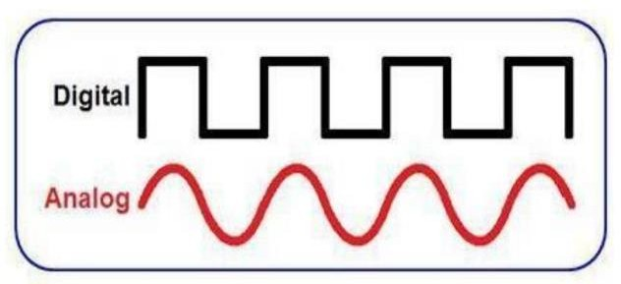Codes were often used to keep the information secret or break it into pieces manageable by technology. Digital signals could be processed by digital circuit components, using less bandwidth and electromagnetic interference. Information storage was easier in digital systems than in analog ones. The noise immunity of digital systems allowed data to be stored and retrieved

without degradation. ICs had two main advantages over discrete circuits: cost and performance. A logic gate was an elementary building block of a digital circuit, with two inputs and one output.

|  |  |
| --- | --- |
| **Operation** | **Expression** |
| AND | Y = AB |
| OR | Y = A+B |
| NOT | Y = A' |
| XOR | Y = AB' + A'B |
| NAND | Y= A' + B' |
| NOR | Y= A' B' |

## AND Operation:

The AND operation produces a high if all the inputs are high. Here is the symbol and Truth Table of AND gate.

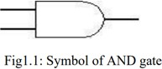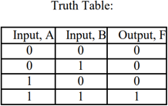

## Pin configuration for IC-74HC08N:

74HC series devices are designed to work with a 5V power supply, allowing voltages from 2V to 5V for most circuits.

## OR Operation:

The OR operation produces a high output when any of the inputs are high. Here is the symbol and Truth Table of OR gate.

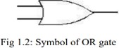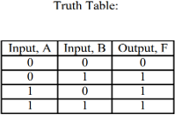

## Pin configuration for IC-74HC32N:

74HC32 is a Quad 2-input OR gate with low current consumption and wide voltage range, with high noise immunity characteristics.

## NOT Operation:

The NOT operation is implemented by an inverter to change one logic level to another. Here is the symbol and Truth Table of NOT gate.

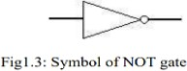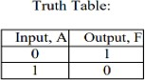

## Pin configuration for IC-74HC04N:

The 74HC04 is a hex inverter with six inverters, clamp diodes, current limiting resistors, and CMOS input level.

## XOR Operation:

The XOR gate acts like a logical "either/or" gate, with the output being high if either input is high, low if both inputs are low, or 0 if both inputs are the same. Here is the symbol and Truth Table of XOR gate.

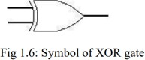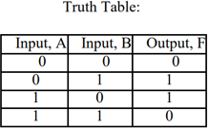

## Pin configuration for IC-74HC86N:

HC86 is a quad 2-input XOR gate with advanced silicon gate CMOS technology, low power consumption and high noise immunity. It has a voltage range of 2V-5V and an input current of 1A.

## Part II:

**Study of Universal Gates:**

Universal Gates are Logic Gates that can be used to create any Logic Gate, such as NOT, AND, OR, XOR, XNOR, etc. NAND and NOR Gates are examples of Universal Gates.

The objective of this lab is to implement different logic functions using universal gates.

## NAND operation:

The NAND gate acts as an AND gate followed by a NOT gate, resulting in a high output if both inputs are high. Here is the symbol and Truth Table of NAND gate.

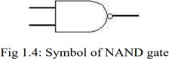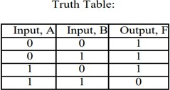

## Pin configuration for IC-74HC00N:

The device code HC00 is compatible with Standard CMOS outputs, with an operating voltage range of 2.0-5 V and low input current of 1.0 A.

## NOR operation:

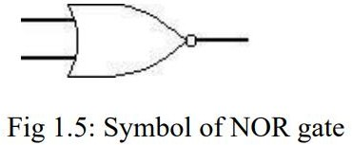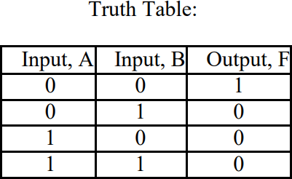The NOR gate is a combination OR gate followed by an inverter with a low output if both inputs are low. Here is the symbol and Truth Table of NOR gate.

## Pin configuration for IC-74HC02N:

The 74HC02 is a high-speed Si-gate CMOS device with a quadrature 2 -input NOR function and a low input current of 1.0 A.

# Apparatus:

* Digital trainer board.
* IC or Integrated Circuits (7400,7402,7404,7408,7432,7486)
* Power supply.
* Connecting wires.
* LEDs (green and red)

# Experimental Procedure:

* + Ensured all components needed were ready to use.
  + Digital trainer board was set up first and provided with a power source relevant to each of the IC(4V).
  + Each IC of different logic gates were chosen to place on the digital trainer board.
  + Excluding the 1st and 14th IC connection we tried specific sequences according to the specific logic gates to create logic output.
  + One power switch for NOT gate and two switches for other gates were always connected to the IC sequence diagram input.
  + One red LED was connected with the IC sequence diagram output. AND green LEDS were connected to the input.
  + According to the truth table of different logic gates. Variations were performed.

# Circuit Diagram:

## Implementing AND gate, OR gate & NOT gate using NAND gate:

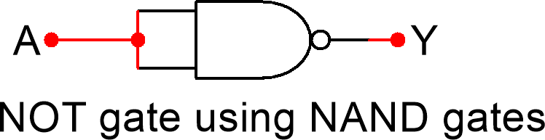

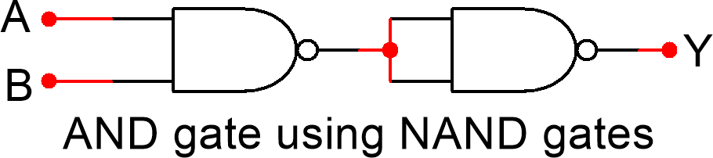

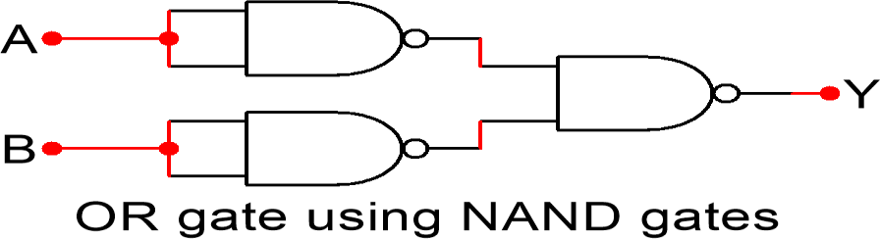

**Implementing AND gate, OR gate & NOT gate using NOR gate:**

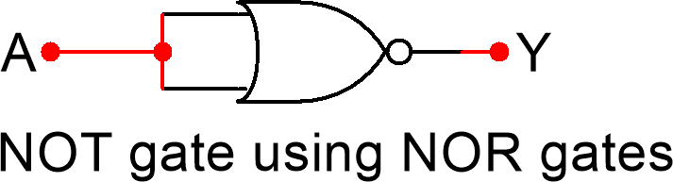

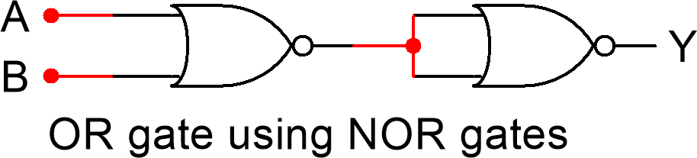

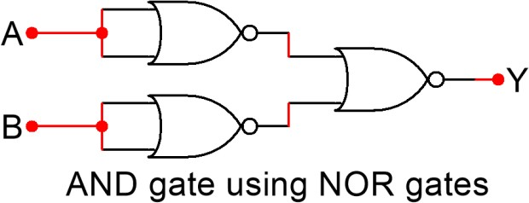

# Images:

## NOT gate:

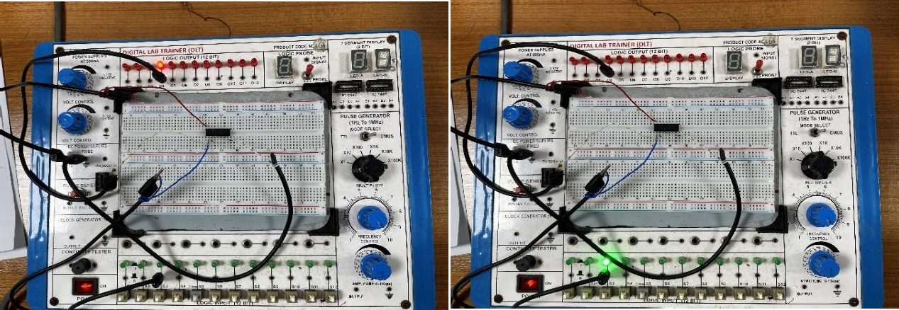

**OR gate:**

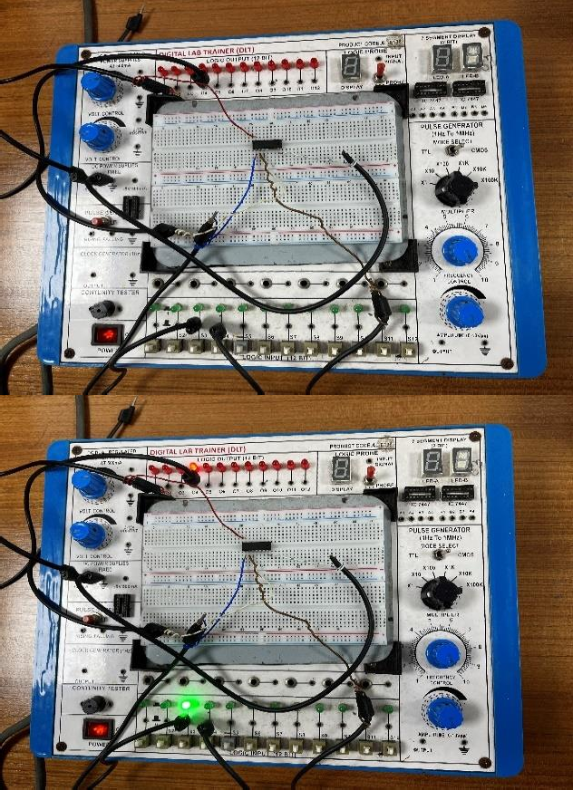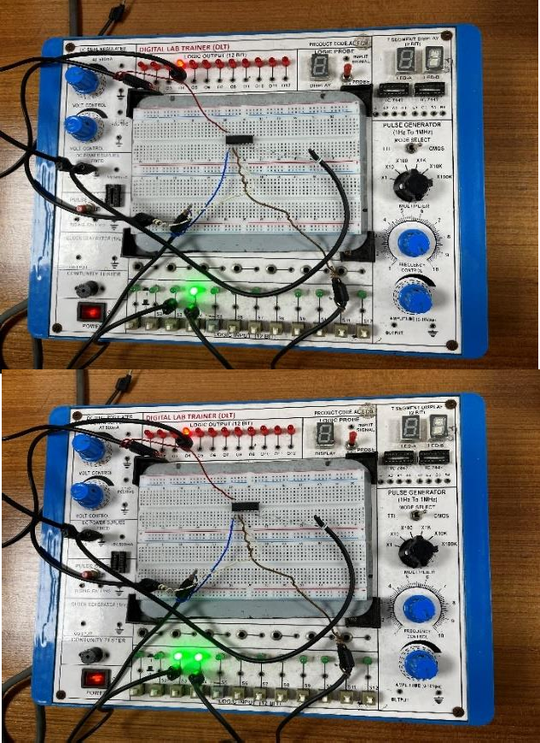

## AND gate:

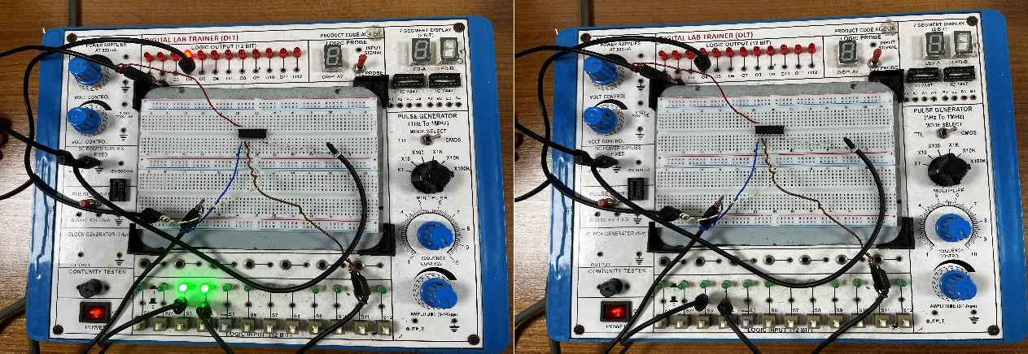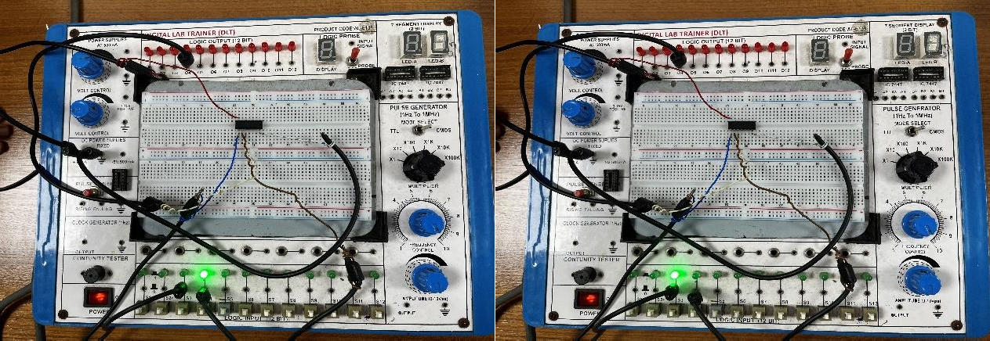

**NAND gate:**

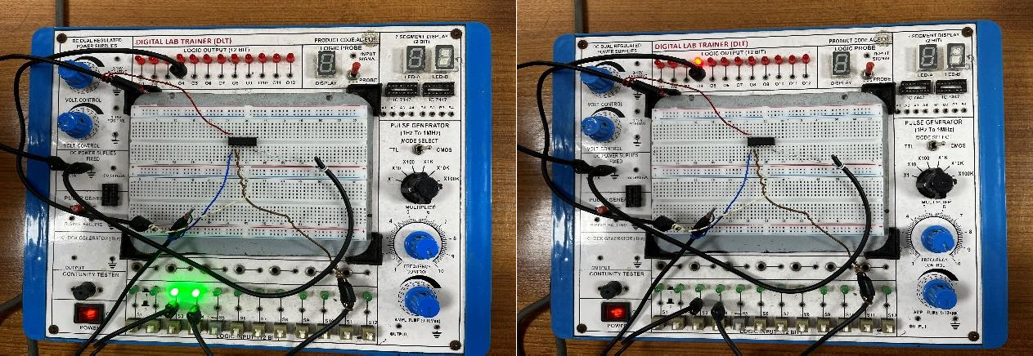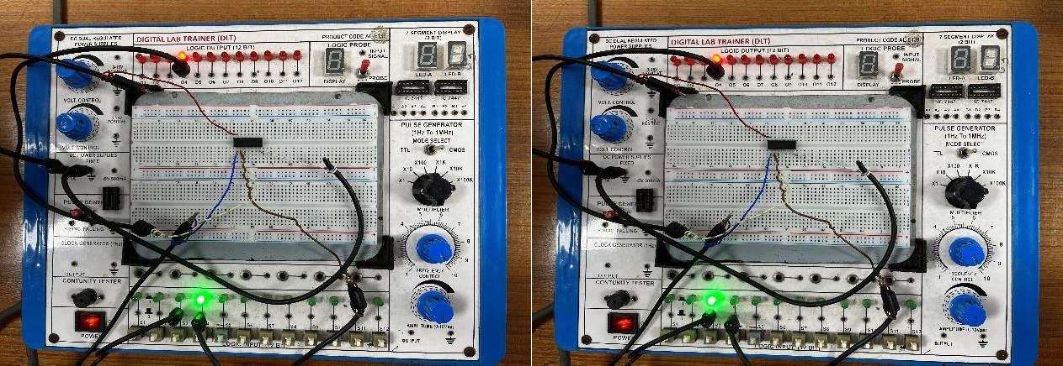

## NOT gate implementation using NAND gate:

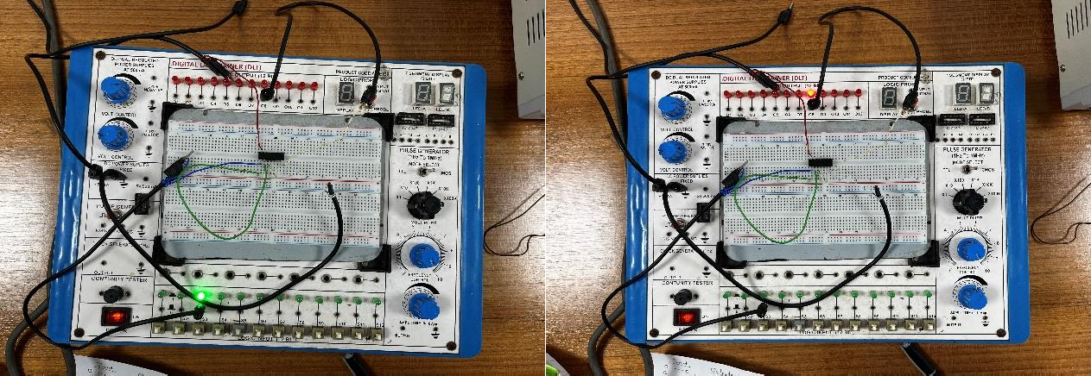

**OR gate implementation using NAND gate:**

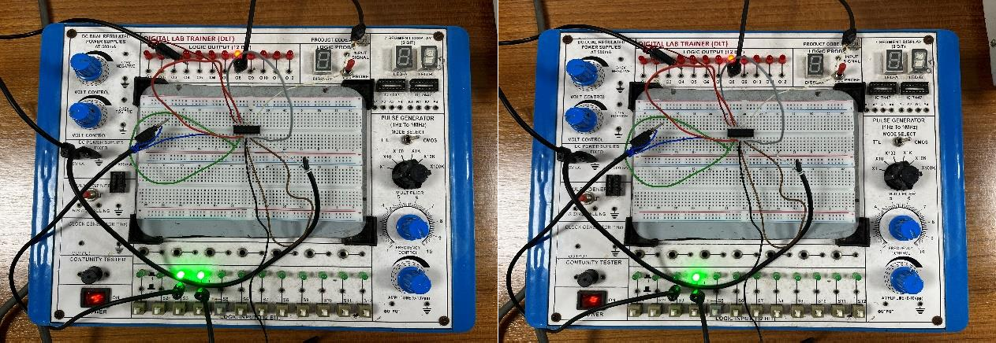

## AND gate implementation using NAND gate:

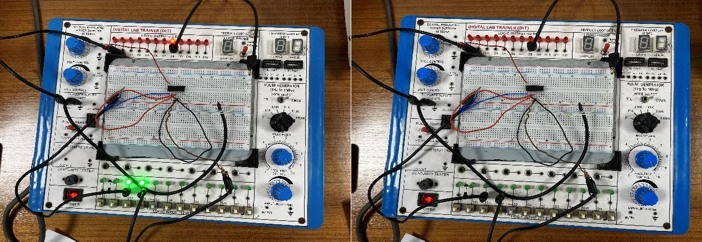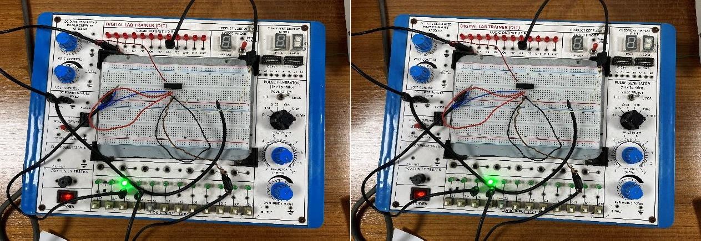

**NOT gate implementation using NOR gate:**

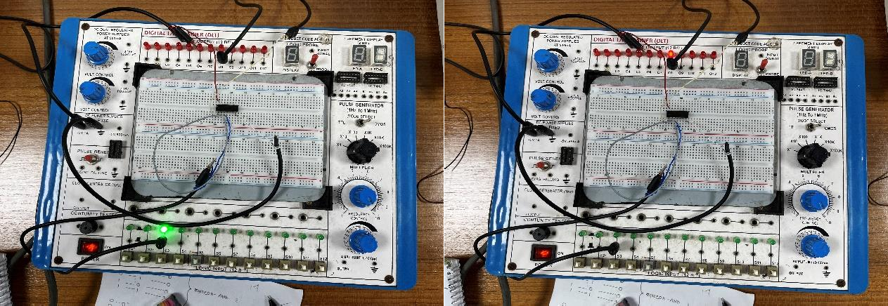

## OR gate implementation using NOR gate:

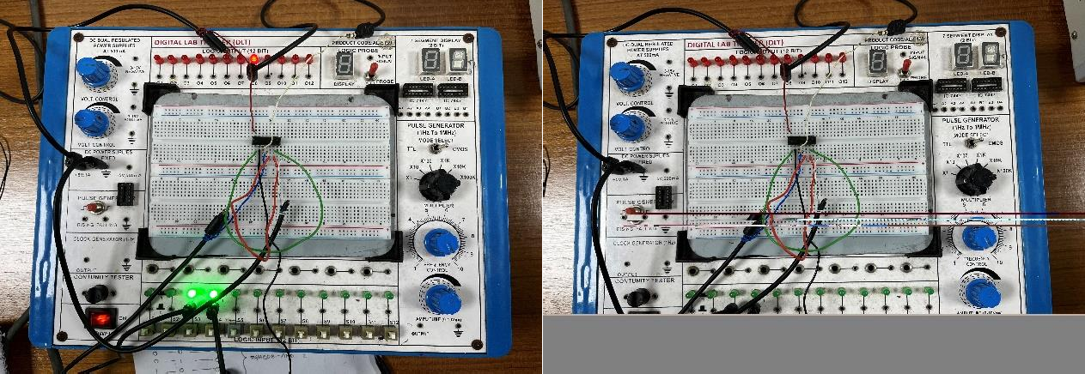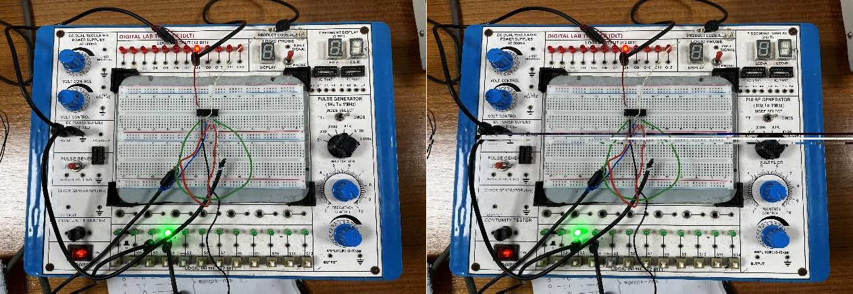

**AND gate implementation using NOR gate:**

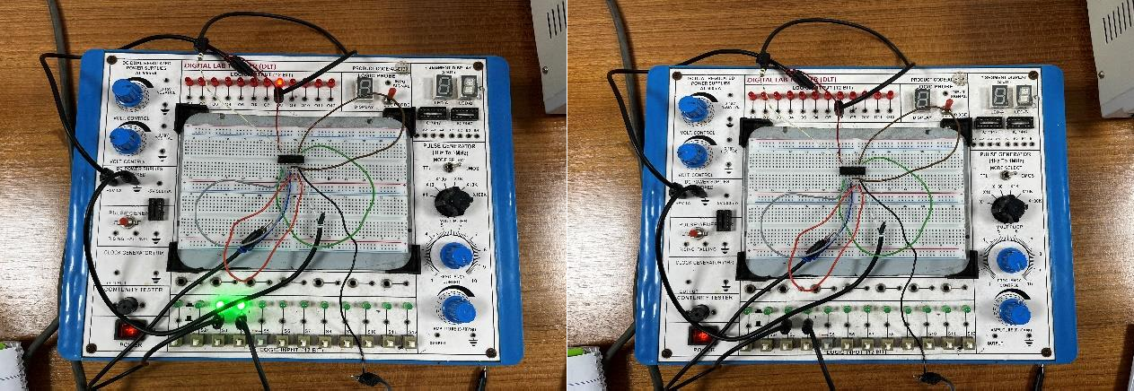

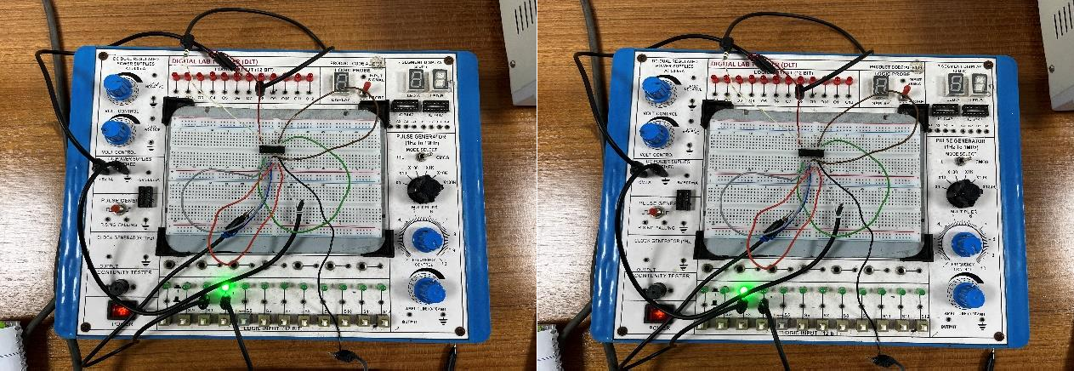

|  |  |  |
| --- | --- | --- |
|  |  |  |
|  |  |
|  |
|  |  |
|  |
|  |  |
|  |
|  |  |
|  |
|  |  |
|  |
|  |  |
|  |
|  |  |

|  |  |  |  |
| --- | --- | --- | --- |
|  |  |  |  |
|  |  |
|  |  |
|  |  |
|  |  |
|  |  |
|  |  |
|  |  |
|  |  |
|  |  |
|  |  |
|  |  |
|  | |
|  |  |

|  |  |  |  |
| --- | --- | --- | --- |
|  |  |  |  |
|  |  |
|  |  |
|  |  |
|  |  |
|  |  |
|  |  |
|  |  |
|  |  |
|  |  |
|  |  |
|  |  |
|  | |
|  |  |

# IC Configuration:

7400

7402

7404

7408

7432

7486

|  |  |  |
| --- | --- | --- |
|  |  |  |
|  |  |
|  |
|  |  |
|  |
|  |  |
|  |
|  |  |
|  |
|  |  |
|  |
|  |  |
|  |
|  |  |

|  |  |  |  |
| --- | --- | --- | --- |
|  |  |  |  |
|  |  |
|  |  |
|  |  |
|  |  |
|  |  |
|  |  |
|  |  |
|  |  |
|  |  |
|  |  |
|  |  |
|  | |
|  |  |

|  |  |  |  |
| --- | --- | --- | --- |
|  |  |  |  |
|  |  |
|  |  |
|  |  |
|  |  |
|  |  |
|  |  |
|  |  |
|  |  |
|  |  |
|  |  |
|  |  |
|  | |
|  |  |

|  |  |  |
| --- | --- | --- |
| 01 | 1A Vcc 1B 4B  1Y 4A  2A 4Y  2B 3B  2Y 3A  GND 3Y | 14 |
| 02 | 13 |
| 03 | 12 |
| 04 | 11 |
| 05 | 10 |
| 06 | 09 |
| 07 | 08 |
|  |  |

|  |  |  |
| --- | --- | --- |
| 01 | 1Y Vcc  1A 4Y  1B 4B  2Y 4A  2A 3Y  2B 3B  GND 3A | 14 |
| 02 | 13 |
| 03 | 12 |
| 04 | 11 |
| 05 | 10 |
| 06 | 09 |
| 07 | 08 |
|  |  |

|  |  |  |
| --- | --- | --- |
| 01 | 1A Vcc  1Y 6A  2A 6Y  2Y 5A  3A 5Y  3Y 4A  GND 4Y | 14 |
| 02 | 13 |
| 03 | 12 |
| 04 | 11 |
| 05 | 10 |
| 06 | 09 |
| 07 | 08 |
|  |  |

|  |  |  |
| --- | --- | --- |
| 01 | 1A Vcc 1B 4B  1Y 4A  2A 4Y  2B 3B  2Y 3A  GND 3Y | 14 |
| 02 | 13 |
| 03 | 12 |
| 04 | 11 |
| 05 | 10 |
| 06 | 09 |
| 07 | 08 |
|  |  |

|  |  |  |
| --- | --- | --- |
| 01 | 1A Vcc  1B 4B  1Y 4A  2A 4Y  2B 3B  2Y 3A  GND 3Y | 14 |
| 02 | 13 |
| 03 | 12 |
| 04 | 11 |
| 05 | 10 |
| 06 | 09 |
| 07 | 08 |
|  |  |

|  |  |  |
| --- | --- | --- |
| 01 | 1A Vcc  1B 4B  1Y 4A  2A 4Y  2B 3B  2Y 3A  GND 3Y | 14 |
| 02 | 13 |
| 03 | 12 |
| 04 | 11 |
| 05 | 10 |
| 06 | 09 |
| 07 | 08 |
|  |  |

**MULTISIM:**

## PART I:

**Simulation for NOT gate:**

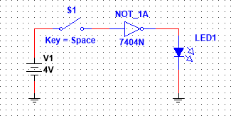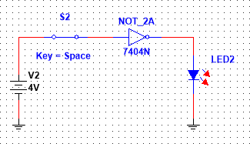

## Simulation for OR gate:

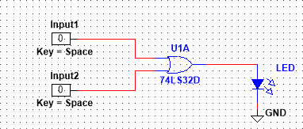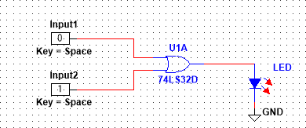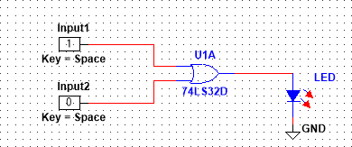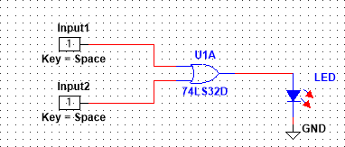

**Simulation for AND gate:**

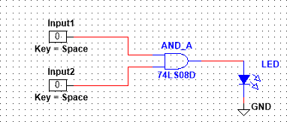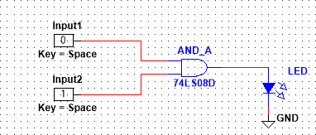

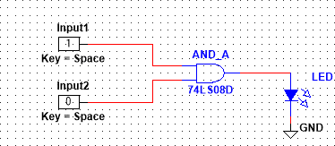 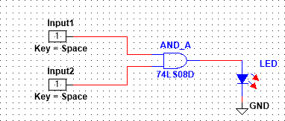

## Simulation for NAND gate:

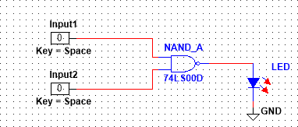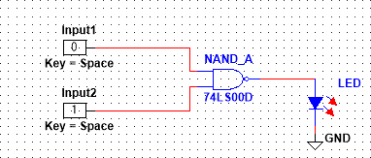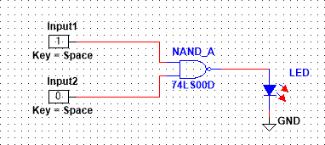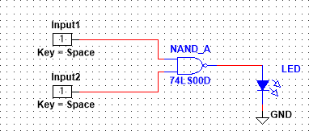

**Simulation for NOR gate:**

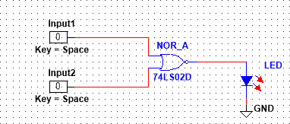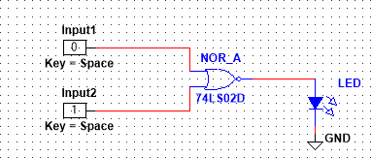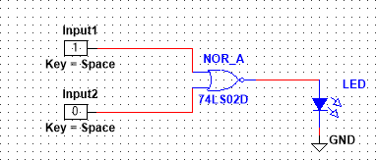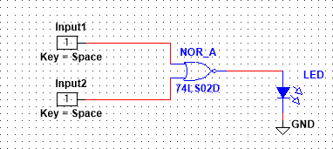

## Simulation for X-OR gate:

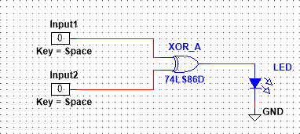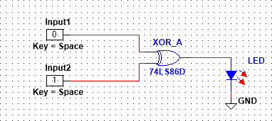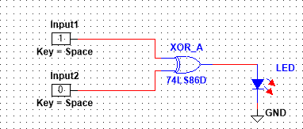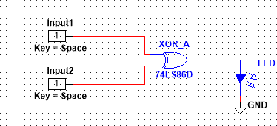

**PART II:**

## Implementing NOT gate using NAND gate:

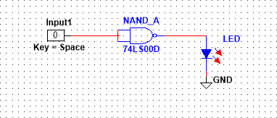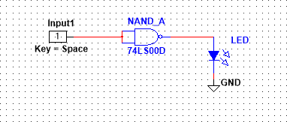

**Implementing OR gate using NAND gate:**

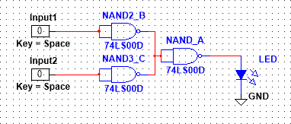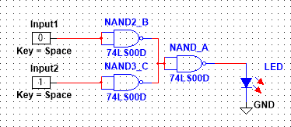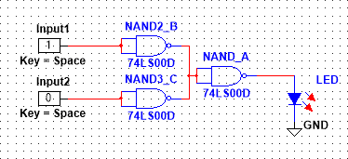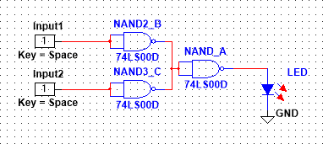

## Implementing AND gate using NAND gate:

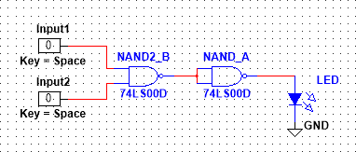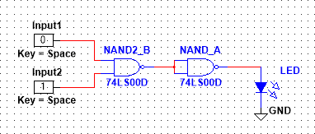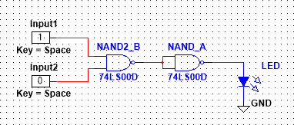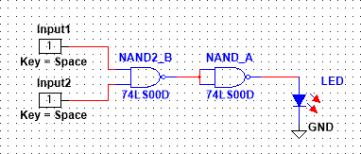

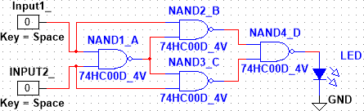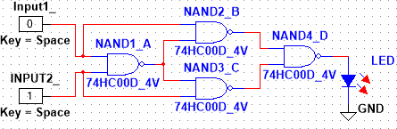**Implementing XOR gate using NAND gate:**

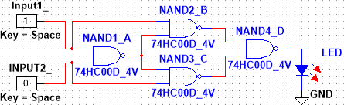 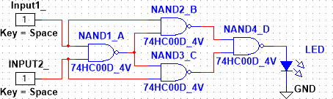

## Implementing NOT gate using NOR gate:

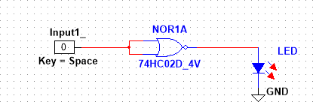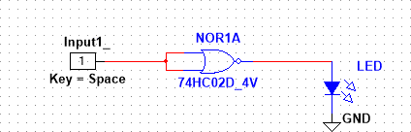

**Implementing OR gate using NOR gate:**

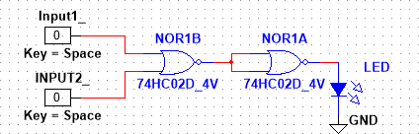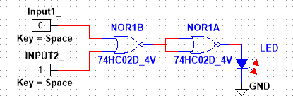

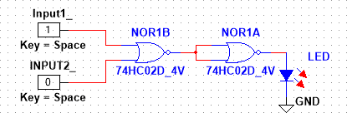 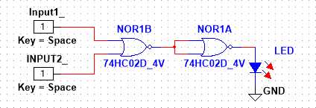

## Implementing AND gate using NOR gate:

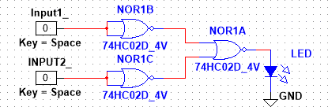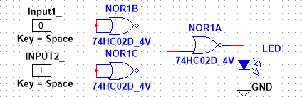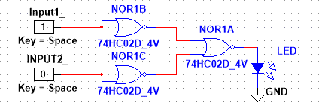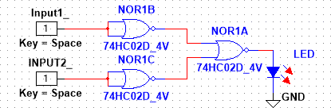

**Implementing XOR gate using NOR gate:**

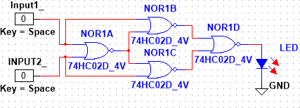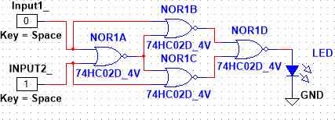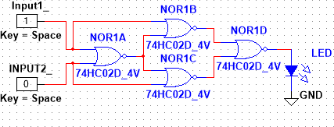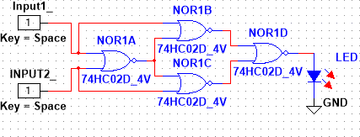

# Discussion and Conclusion:

In this experiment, we have used Multisim software for Simulations. While using this, we faced some problems. Overall, using the software to locate the solution was simple, and a beginner's ability to draw a circuit was average. Firstly, we need to understand truth-table and the design oflogic gates.

Afterward, we can decide how to prepare for working with Multisim Software. We have successfully and error-free assembled all the components in the breadboard. We have successfully verified that there are no issues in connecting the circuit wires. At last, the Truth-table for the logic gates were verified by the results and simulations and they matched with each other.

# Reference:

“Digital Fundamentals” by Thomas L. Floyd

* + - [www.tutorialspoint.com](http://www.tutorialspoint.com/)
    - [www.electronics-tutorials.ws](http://www.electronics-tutorials.ws/)
    - [www.faculty.kfupm.edu.sa](http://www.faculty.kfupm.edu.sa/)

**Questions with Answers:**

1. **What do you mean by universal gate?**

**Ans:** A universal gate refers to a logic gate that can be used to implement any other type of logic gate. In other words, a universal gate has the capability to perform the functions of all other basic logic gates, such as AND, OR, NOT, NAND, NOR, and XOR gates. By using a combination of universal gates, any logical function can be realized.

The two most common universal gates are the NAND gate (NOT-AND) and the NOR gate (NOT-OR). This means that any logical expression or circuit can be constructed using only NAND gates or NOR gates. These gates are considered universal because they can perform all the logical operations required to implement any digital system.

1. **What are the ICs required in this experiment?**

**Ans:** In the first part of the experiment where an X-OR gate is constructed using only NAND gates, the specific ICs required would depend on the number of inputs and outputs desired for the gates. NAND gates can be implemented using various ICs, such as 74LS00, 74HC00, CD4011, or CD4093, among others. These ICs typically contain multiple NAND gates in a single package. We have used 74HC00 in this experiment.

In the second part of the experiment where an X-OR gate is constructed using only NOR gates, again the choice of ICs would depend on the desired number of inputs and outputs. NOR gates can be implemented using ICs like 74LS02, 74HC02, CD4001, or CD4002, among others. These ICs usually contain multiple NOR gates in a single package. We have used 74HC02 in this experiment.

The specific ICs needed may vary based on the trainer board or equipment being used and the availability of different ICs. It's important to refer to the documentation or specifications of the trainer board or consult the experiment guidelines for the recommended ICs to be used in the circuit construction.